**List of changes on the manuscript titled: (Finger Texture Biometric Characteristic: A Survey)**

First of all, we would like to thank the main Editor, the Associate Editor and the anonymous reviewers for their valuable efforts and time to review and enhance the manuscript. We have carefully considered all the comments from the reviewers and the manuscript has been revised thoroughly as detailed in the response to the reviewers’ comments. All the raised points have been covered.

In the sequel, detailed responses to all comments are listed. The addressed points have been highlighted in yellow for both the responses file and the revised manuscript.

**Editor-in-Chief**

**(1) Comment: *“The paper presents a survey about FT. The leading author, Prof. Chambers has published similar topics before in [36,37]. [37] is cited many times in this paper, however, the topic is the same, and it has published last year in DSP J. I do not think that this new paper could give much more on the State-of-the-Art in [37]. This paper can be interpreted as a detailed Intro about SoA of the previous [37] publication in DSP by the same group.”***

**Response:** First of all, we would like to give you our thanks for giving us the opportunity to revise and resubmit the manuscript again. Moreover, we think that paper [37] has presented significant contributions in the field of Finger Texture (FT), especially in feature extraction and multi-object fusion. As a survey paper we have to consider this paper in both of these sections in order to produce comprehensive study.

**(2) Comment: *“Moreover, the scope of this survey paper is too broad and does not provide sufficient insight and focus into finger texture biometric. For this reason I recommend to publish this paper in a different, biometrics oriented journal.”***

**Response:** Fundamentally, the subject of FT belongs to image processing and pattern recognition fields. Both of these fields are parts of the digital signal processing area. We think the manuscript is suitable for this journal.

**(3) Comment: *“The article presents a thorough review analysis of finger-based biometric systems. However this review has few if any insights in Digital signal processing techniques, reason why I believe a more target oriented journal is a better much for this submission.”***

**Response:** Please see the response of comment (2).

**Reviewer 1**

**(1) Comment: *“This paper presents a survey of finger texture biometric. Some grammatical errors were spotted in the paper such as:***

***Page 9 Line 2-3: "fusion or combination with other biometric characteristics does not important to be considered."***

***Page 9 Line 22: "what is about amputating a certain finger?."***

***Page 12 last line: "In contrast with the FT, the FT is more user-friendly."***

***Page 25 Line 22: "which is was found to..."”***

**Response:** The mentioned grammatical errors have been corrected in the new manuscript as follows:

- fusions or combinations with other biometric characteristics are not important to be considered.

- what is about amputating the exploited finger?.

- In contrast, the FT is more user-friendly.

- which was found to...

**(2) Comment: *“The paper should be thoroughly proofread first.”***

**Response:** This has been addressed.

**(3) Comment: *“In Table 1, a comparison is made to determine the acceptability, reliability, collectibility, applicability and security level of various finger physiological characteristics. However, the comparison result of high, moderate or low level is purely based on the authors' opinion and is not supported by any data or survey.”***

**Response:** Supported references have been included for Table 1.

**(4) Comment: *“In Section 7, several databases were presented. Some sample images of each database should be presented too.”***

**Response:** This has been addressed to all databases in section 7.

**(5) Comment: *“In general, the scope of this survey paper is too broad and does not provide sufficient insight and focus into finger texture biometric. For example, CASIA palmprint image database (Section 7.3) is meant for palmprint instead of finger texture, and is of insignificant relevance to the topic of the paper.”***

**Response:** In our manuscript, we have explained that “… several hand image databases, which are generally acquired for their palmprints, could be employed since FTs can be segmented from the fingers of these images. …”. The reason of reporting the databases of palmprint images in this survey is that they have been used in FT studies.

**Reviewer 2**

**(1) Comment: *“The paper presents a comprehensive study for the Finger Texture (FT). The authors also present the main drawbacks and obstacles of employing the FT as a biometric characteristic. As a whole, the paper is well written and structured. Data analysis also shows that the work carried out is sound and promising, but some minor adjustment are required to make the manuscript worthy to be published.”***

**Response:** Thank you for this comment.

**(2) Comment: *“Some of issues that need to be addressed are given below:***

***1.The paper is well organized, but authors need to add more up-to-date articles published in 2018 and 2019.”***

**Response:** This has been addressed.

**(2) Comment: *“2.Although the authors provide a comprehensive overview of the various methods of FT, the authors did not give the URL of open source methods. These methods' codes are very useful for researchers.”***

**Response:** URLs have been included.

**(3) Comment: *“3.The authors present a fairly valuable study in Section 7 Employed Databases in FT Studies. However, the authors should present several representative images for each database to better distinguish them more intuitively.”***

**Response:** This has been addressed to all databases in section 7.

**Reviewer 3**

**(1) Comment: *“The amount of work behind the present article is impressive and it definitely worth considering.”***

**Response:** Thank you for this comment.

**(2) Comment: *“However, I do have some observations, as follows.***

***In the introduction on line 5, authors refer to "high security level systems". Are there low security level systems as well? Please provide references and be specific to exactly what kind of systems (with high security level) you refer to. Also, when considering "products and buildings", do authors refer strictly to access systems for buildings? Is there any reason to consider only these systems?”***

**Response:** We meant the biometric technologies that are using more than one biometric characteristic. You are right about the expression of "high security level systems" as we have not mean there are low security level systems. We have clarified the meanings in the new manuscript as follows:

Biometric recognition can be considered as one of the most important components of a large number of security systems. Examples of some technologies which can employ a biometric characteristic to authenticate the automatic access 5 are mobile phones, laptops, private computers and Automated Teller Machines (ATMs) [1]. Efficient biometric systems that are using more than one biometric characteristic can be found specifically in some very high security buildings. Without biometric recognition such products and buildings may be attacked by unlicensed or unauthorized people.

**(3) Comment: *“The Figure 1 could be organized as a table, as most part of the figure contains no information, just one cloud and several arrows.”***

**Response:** The issues have been addressed as follows:

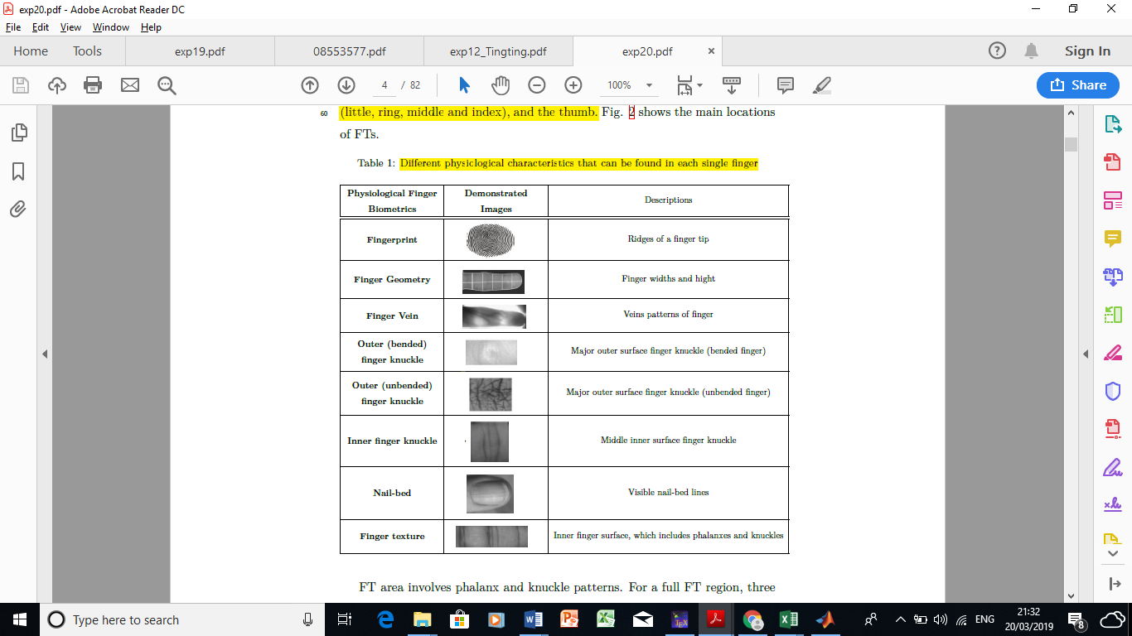

**(4) Comment: *“The image in Fig. 2 looks as it was processed. Please indicate the algorithms that were applied (and why). If the image is from [5], do authors have the permission to use the image?”***

**Response:** The mentioned figure is useful as it has all the inner surface patterns. This figure has been taken from a reference. Also, we have asked for the authors permission, unfortunately we have got no answer. We have clearly cited this reference in the figure title:

Figure 1: Various patterns that formed the inner surface of a finger: ridges, visible lines and

skin wrinkles as given in [5]

**(5) Comment: *“Regarding Fig. 3, please indicate how the rectangles were determined, especially if they were determined automatically. The rectangles showing the regions themselves are enough to make the point. I suggest removing the arrows and the rectangle reading "main locations of FTs" which says basically the same as the caption of the figure.”***

**Response:** The rectangles are determined according to [6]. Now, fig. 3 and its caption have been adjusted in the new manuscript as suggested in this comment:

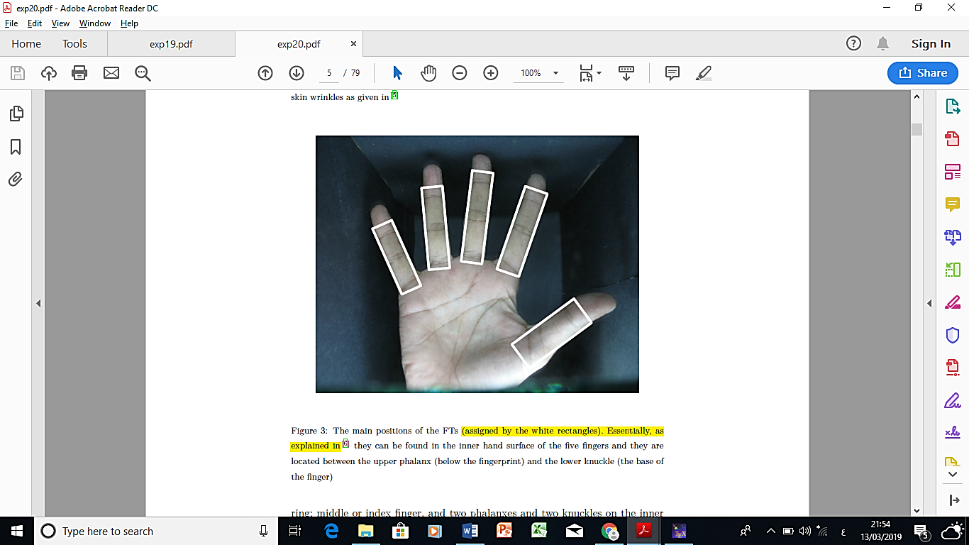

**(6) Comment: *“All the enumerations on pages 5 an d6 could be inline, in one single paragraph, for aesthetic reasons.”***

**Response:** All the mentioned enumerations have been adjusted in the new manuscript as:

The three types of phalanxes for the four fingers are: (1) upper phalanx (below the fingerprint) called distal; (2) middle phalanx named intermediate and (3) lower phalanx termed proximal.

The three types of knuckles for the four fingers are: (1) upper knuckle between the distal and intermediate phalanxes; (2) middle knuckle between the intermediate and proximal phalanxes and (3) lower knuckle near the palm.

The two types of phalanxes for the thumb are: (1) upper phalanx (below the fingerprint) called distal and (2) lower phalanx termed proximal.

The two types of knuckles for the thumb are: (1) upper knuckle between the distal and (2) intermediate phalanxes and lower knuckle near the palm.

**(7) Comment: *“Text font size in Fig. 4 and 5 should be smaller. The Fig. and 5 could be merged into a single figure, as they both provide examples of the same concepts emphasized for two different fingers.”***

**Response:** Font size and figures 4-5 have been adjusted in the new manuscript as:

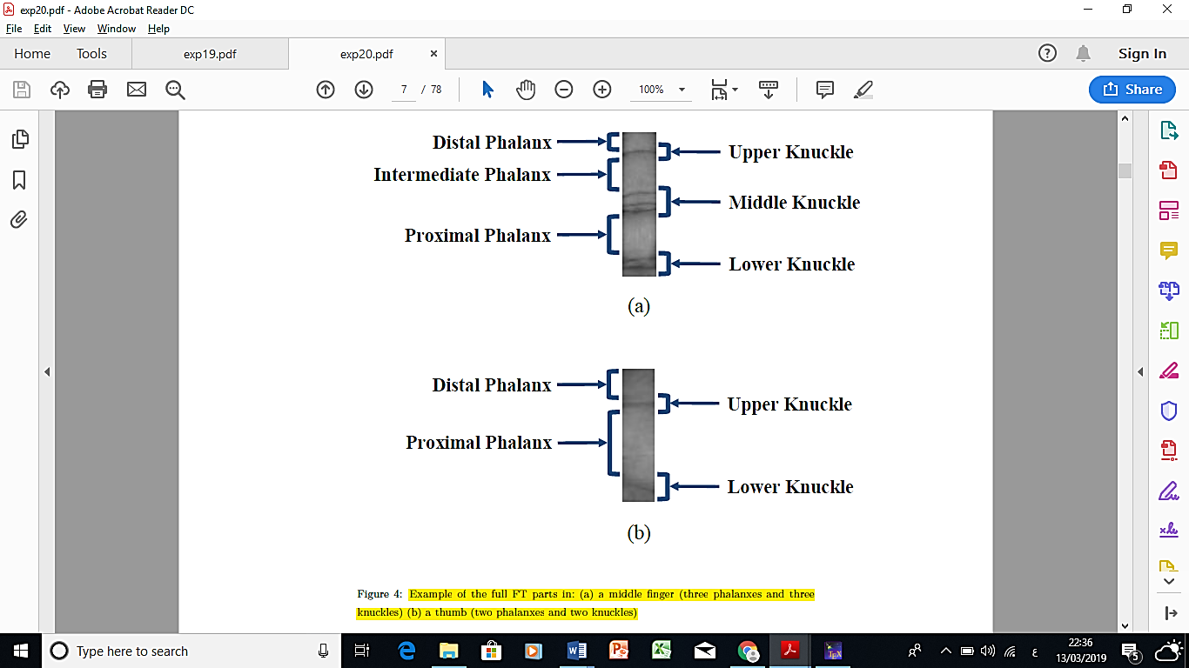

**(8) Comment: *“First paragraph at the beginning of Section 2 (page 7, line 95) is to telegraphic, it should be properly rephrased.”***

**Response:** This has been addressed as follows:

“… general overview for different physiological finger characteristics will be provided; ….”

**(9) Comment: *“Page 7, line 100: what authors mean by "beneficial" when referring to features? Further on, on line 105, what do authors mean by "its traits can be collected without requiring a certain finger to be presented"?”***

**Response:** The word “beneficial” in the old manuscript meant “constructive” and this has been clarified in the new manuscript. Secondly, we meant by “its traits can be collected without requiring a certain finger to be presented” that “a fingerprint can be collected from its trace (fingermark)”, this also has been clarified in the new manuscript.

**(10) Comment: *“No references are provided to support the statement in paragraph 115 on page 8 - "in contrast to the FT, the visible lines and skin wrinkles of the FT are more reliable and permanent". Moreover, why for FT the acquisition devices can have lower resolution******, compared with the ones used for fingerprints?”***

**Response:** Firstly, the mentioned sentence has been supported by a reference now in the new manuscript. Secondly, the FT acquisition devices can have lower resolution compared with the ones used for fingerprints because the (minutiae) patterns of the fingerprints require more resolution acquisition devices than the main patterns (vertical and horizontal lines) in the FT as they are more visible and can be easily seen.

**(11) Comment: *“Page 8, line 120: is the binarization the only approach for hand region segmentation / identification?”***

**Response:** Yes, the binarization is the only approach for hand region segmentation / identification in terms of collecting the geometry of fingers as highlighted in [26].

**(12) Comment: *“Page 8. Line 130: the statement "in contrary to the FT, the security level that provided by the FT is very high" makes no sense to me. Also please provide some references for that statement. In the same paragraph, please define ROI in the introduction - which is mentioned here for the first time. What could be/is considered as ROI for FT?”***

**Response:** Now, in the new manuscript, references have been included for the mentioned statement and the ROI issue has been addressed. The ROIs of FTs are explained in the “Segmenting the FT Regions” section, specifically in the “Full FT region” part.

**(13) Comment: *“Page 9, paragraph 135: please rephrase and provide references to support the statement.”***

**Response:** These issues have been addressed in the revised manuscript as follows:

“Moreover, the FTs of different fingers can be exploited together to produce a high recognition biometric system [32,33,6], therefore, fusions or combinations with other biometric characteristics are not important to be considered.”

**(14) Comment: *“As far as I know the veins are not inside the skin. Which layer of the derma? Pease be specific and use the appropriate medical terms.”***

**Response:** Thank you for this insightful comment. This has been investigated and corrected in the new manuscript as:

“FV is a biometric pattern that commonly positioned close to the proximity of the skin of a hand [34].”

**(15) Comment: *“Page 9, line 141: the NIR environment refers to the acquisition system?”***

**Response:** Yes, this has been clarified in the new manuscript as:

“Such a biometric requires a specific Near-InfraRed (NIR) environment in the acquisition system”

**(16) Comment: *“Page 9, line 145: what do authors mean by "invisible patterns" and why they should be considered if invisible? Not clear to me.”***

**Response:** The mentioned “invisible patterns” meant “unclear patterns (because of undistributed illumination)” and this has now been clarified in the new manuscript.

**(17) Comment: *“Page 9 line 155; please rephrase "what is about amputating a certain finger".”***

**Response:** The mentioned statement has been rephrased in the new manuscript as:

“what is about amputating the exploited finger?.”

**(18) Comment: *“Line 157, please reconsider*** ***the statement "Comparing with the FT, there is no restrictions for using special acquisition device or environment". Some minimal requirements (e.g. image resolution) must be considered.”***

**Response:** In the statement "Comparing with the FT, there is no restrictions for using special acquisition device or environment", the focusing here is on “using special acquisition”. Because there is no special acquisition requirement to collect the FTs we mentioned that. However, there are some affordable requirements. So, this has been clarified in the new manuscript as:

Comparing with the FT, there is no restrictions for using special acquisition device or environment but there are some affordable requirements.

**(19) Comment: *“Regarding "FOKs are unique and reliable patterns" - all of them (FG, FV… ) are unique and reliable. This statement is misleading and not appropriate.”***

**Response:** This statement has been removed in the revised manuscript.

**(20) Comment: *“Page 10 line167: the FOK pattern is believed to be distinctive and varies between the fingers rather than the individuals - one can read that FOK could be the same (identical) for different individuals?”***

**Response:** In fact, this statement is true as it has been improved by many studies such as [43,44,45,46,47,48,50,51].

**(21) Comment: *“"FOK offers different texture views according to various bending degrees" applies to other characteristics as well, e.g. FV. Please reconsider.”***

**Response:** This has been considered as:

“Different finger bending degrees afford various FV features too.”

**(22) Comment: *“Page 10 line 180: "there are several difficulties associated with this data base" - please rephrase.”***

**Response:** The sentence has been rephrased as follows:

This database has some drawbacks.

**(23) Comment: *“Page 11, line 195: constancy in terms of what?”***

**Response:** Constancy compared to other fingers. This has now been clarified in the new manuscript as:

“… it provides satisfactory constancy compared to other fingers during capturing the finger dorsal image …”

**(24) Comment: *“Page 11 line 200: reliability if not considered in the introduction as characteristic of the biometric systems. Or at least, a clear separation between the characteristics of the systems and of the traits should be made.”***

**Response:** In the case of reliability, a clear separation between the characteristics of the systems and of the traits has been made in the new manuscript. The reliability is considered now for the trait characteristics only.

**(25) Comment: *“Page 11 line 207: please be more specific about "a large box". What kind of box? Again, be more specific about "suitable lighting" and, later on, "user-friendly capturing" on line 214.”***

**Response:** These issues have been addressed in the revised manuscript as follows:

* a large box which covers the full view of FOK patterns
* suitable lighting inside for clarifying the FOK features
* it is more user-friendly during capturing its features than the FOK.

**(26) Comment: *“Page 11 line 221: please define the "******main fingers" in the introduction.”***

**Response:** The “main fingers” are defined in the introduction of the revised manuscript as follows:

The FTs can be found on the inner surface of five fingers: the four fingers or main fingers (little, ring, middle and index), and the thumb.

**(27) Comment: *“Page 12 line 231: what exactly the authors mean by "richer patterns"? In terms of what, from the point of view of texture characteristics (allowing for a quantitative evaluation)? Density, orientation etc?”***

**Response:** This has now been clarified in the new manuscript as:

“… a richer pattern (more visible lines) than the upper knuckle …”

**(28) Comment: *“Page 13, line 257: the security level of features is not mentioned before. Authors should be consistent first of all with the characteristics (both of systems and considered features as pointed out before) and secondly when comparison of each trait / feature is performed against FT - the comparison should be performed from the point of view of the same characteristics for all features.”***

**Response:** In fact the security level for the FIK was highlighted in line 256 of page 13 (in the original manuscript). Nevertheless, in the revised manuscript the comparisons have been rearranged in order to get satisfied consistency:

Now comparing with the FT, a FIK is only a small part of the FT. The area of the FT covers more features than the small area of the FIK. Thumbs have been considered in many FT studies and completely ignored in the FIK publications. The security level of the FT is high, because it consists of various patterns such as the reliable patterns of phalanxes.

**(29) Comment: *“Page 14, line 293 - "fancy patterns" - please be more specific.”***

**Response:** This has now been clarified in the new manuscript as:

“Moreover, it involves various types of patterns, these are vertical patterns (the visible lines); horizontal lines (the wrinkles) and ridges.”

**(30) Comment: *“Regarding Table 1: please check the consistency between the characteristics in table 1 and the ones considered/described in the introduction.”***

**Response:** The consistency has been checked. Furthermore, Table 1 has now been supported by references.

**(31) Comment: *“Some references should be provided for the three stages considered in Section 3.”***

**Response:** The references have been included.

**(32) Comment: *“Regarding the conclusions of the paper, the statement "many efficient commercial biometric applications and systems based on FT(s) can be produced" should be rephrased, as it sounds more like a speculation. Regarding the usage of multi-spectral sensors: hyperspectral imaging could also be considered, but please provide some reasons for increasing the spectral resolution for the acquisition devices. This was not clear to me by the end of reading the paper.”***

**Response:** Firstly, the mentioned statement has been rephrased in the revised manuscript as follows:

Biometric application projects and systems based on the FT(s) can be produced.

Secondly, hyperspectral imaging has been considered in the revised manuscript as follows:

Hyperspectral imaging of FTs are worth studying, where interesting FT patterns and textures are revealed according to the afforded electromagnetic spectra.